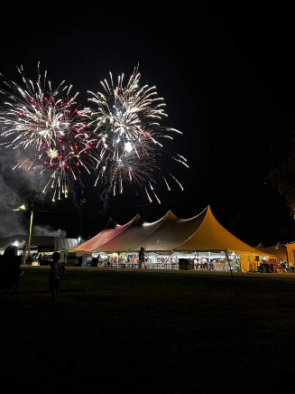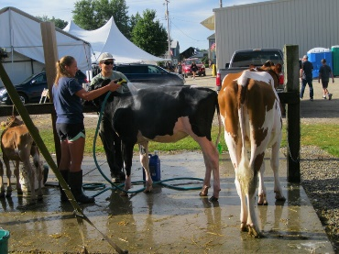

Payment can be made with Check, Cash, or Money order. **(THE FAIR DOSENT ACCEPT PAYPAL AS FORM OF PAYMENT)

All payment can be made to

Jeff Kok

110 Industrial Drive Apt. 805

Beaver Dam, WI 53926

If you have any questions, feel free to reach out to Jeff Kok at 920-219-1325 or Kelly Sullivan at 608-212-8612

Number of Booth spaces needed:___________

Indoor or Outdoor Booth Space:__________________

Would like to reserve a parking spot:______________

*Any comments________________________

_____________________________________

_____________________________________

INDOOR & OUTDOOR Spaces available

1 Booth Space $60

2 Booth Spaces $115

3 Booth Spaces $170

** If you would like to reserve a parking space near the tent for $40. Otherwise, it is first come first serve for parking.

Business Name:_____________________________________________________________

Contact Person:_____________________________________________________________

Address:___________________________________________________________________

Email:_____________________________________________________________________

Phone:____________________________________________________________________

List of Product or services that will be displayed:___________________________________

___________________________________________________________________________

___________________________________________________________________________

ALTO FAIR 2023 VENDOR REGISTRATION FORM